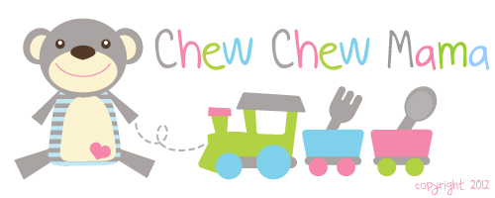

Daily Beverage Intake Log

Water
Milk
Juice
Other

Have you paid much attention to how or when you are giving cups?

Sippy cups may or may not be sabotaging your mealtimes.
Keep track of your child's beverage intake using the attached log to see how cups are affecting your mealtimes. Keep it on your refrigerator and simply place a check in the beverage box when you are giving your child a cup. Jot in the time of day too!

Remember that giving your child milk or juice close to mealtimes will mean that they have already consumed calories that will make them less hungry for what is on their plate. When possible, give water when you are approaching mealtimes.

To make sure you child is well -nourished and hydrated, talk with your pediatrician about what their daily requirements of food and water should be each day based on their age, weight, activity level and climate/temperature exposure.

